Running a Fencing Tournament
Using the Fencing Time Program

by

Colin Walls

Oct 2012
Licence
This document is licenced under the Creative Commons Attribution-ShareAlike 3.0 Unported (CC BY-SA 3.0) licence (full details at https://creativecommons.org/licenses/by-sa/3.0/).
You are free:
- to Share — to copy, distribute and transmit the work
- to Remix — to adapt the work
- to make commercial use of the work
Under the following conditions:
Attribution — You must attribute the work in the manner specified by the author or licensor (but not in any way that suggests that they endorse you or your use of the work).
Share Alike — If you alter, transform, or build upon this work, you may distribute the resulting work only under the same or similar license to this one.
With the understanding that:
Waiver — Any of the above conditions can be waived if you get permission from the copyright holder.
Public Domain — Where the work or any of its elements is in the public domain under applicable law, that status is in no way affected by the license.
Other Rights — In no way are any of the following rights affected by the license:
- Your fair dealing or fair use rights, or other applicable copyright exceptions and limitations;
- The author's moral rights;
- Rights other persons may have either in the work itself or in how the work is used, such as publicity or privacy rights.

Table of Contents

Introduction 1
Glossary 2
Installing Fencing Time 4
Getting a Copy of the Program 4
Set Up 4
Licencing the Program 4
Configuration 4
Customising Displayed and Printed Information 5
Caveats 8
The User Interface 9
Main Menu Bar 9
Main Toolbar 9
Left Side Panel 9
Event windows 10
Preliminaries – Setting up the Database 11
Clubs 11
Importing a Club List 11
Adding Individual Clubs 12
Editing a Club 13
Fencers 13
Importing a List of Fencers 13
Using the BFA Membership Database as the Fencer Database 15
Adding Individual Fencers 15
Rankings 16
Importing Point Ranks 16
Referees 18
Planning the Tournament 19
Timing and Piste Usage 20
Referees 20
Helpers 21
Armourers 21
Directiore Technique 21
Before the Tournament 23
Creating the Tournament 23
The New Event Wizard 24
Date, Time and Cost 25
Gender, Age and Classification 25
Seeding 25
Completing the Event Wizard 29
Adding Competitors 29
Importing Entries 29
Entering Competitors from the Fencer Search Form 32
Validating the Entry List 33
Checking Against the BFA Membership Database 33
Starting the Tournament 34
Check In List 34
Processing the Check In List 34
Starting the Event 35
Poule Rounds 36
Creating the Poules 36
Entering Piste Numbers 38
Announcing the Poules 38
Adding a Late Comer to the Poules 38
Redrawing the Pools 39
Fencer Left out of the Pools 39
Fencer Included Who is Absent 39
Incorrect Draw due to Ranking 39
Incorrect Draw due to Affiliation 39
Entering the Results of the Pools 40
Errors on the Poule Sheet 40
Printing the Results of the Pools 41
Abandoning After the Pools, but Before the Direct Elimination 41
Withdraw or Exclude 41
Ranking After the Poules 41
Direct Elimination 43
Entering Piste Numbers and Times 43
The Turn DE Wizard 44
Printing the Score Sheets 45
Entering the Results 45
Alternative Methods of Running the DE 46
The Single Tableau Method 46
Continuous Fencing 46
In Quarters or Octants 46
Which Method to Use 47
Publishing Interim Results 47
Completion of the Tableau 48
After the Competition 49
Publishing Final Results 49
At the Venue 49
On the Internet 49
Creating Result Packs 49
Who Needs the Results? 49
What to Do When it All Goes Wrong 50
Correcting an Earlier Mistake 50
In the Poules 50
In the DE 50
Restoring a Back Up 50
Copying Data to Another Computer 50
Transferring the Database 50
Copying the Tournament Files 51
Other Reports 52

Index of Figures

Figure 1 Introductory Screen 4
Figure 2: Setting the Default Country 5
Figure 3: Using a Custom Logo 5
Figure 4: A Typical Uncustomised Window 6
Figure 5: Customised Dialogue Window 6
Figure 6: The Fencing Time Main Screen 9
Figure 7: The Clubs Database Main Window 11
Figure 8: The Clubs Import Window 12
Figure 9: Clubs CSV File Contents 12
Figure 10: The Club Fields Dialogue Window 12
Figure 11: New and Edit Club Dialogue 13
Figure 12: The Main Fencer Database Window 14
Figure 13: A Typical Fencer CSV File 14
Figure 14: Importing a List of Fencers 14
Figure 15: Associating File and Database Fields 15
Figure 16: The New and Edit Fencer Dialogue 15
Figure 17: The Point Lists Dialogue 16
Figure 18: Creating a New Points List 16
Figure 19: A Typical Rankings CSV File 17
Figure 20: Ranking Import Type 17
Figure 21: Points List Fields 17
Figure 22: Main Referee Screen 18
Figure 23: The New and Edit Referee Screen 18
Figure 24: Tournament Planning Sheet 21
Figure 25: Creating a New Tournament 23
Figure 26: Tournament Details 23
Figure 27: Event Type and Weapon 24
Figure 28: Setting the Date and Time 25
Figure 29: Selecting the Gender 25
Figure 30: Selecting the Age Group 25
Figure 31: Selecting the Classification 26
Figure 32: Choosing the Ranking Method 26
Figure 33: Ranking from a Points List 28
Figure 34: Choosing the Points List 28
Figure 35: Confirming the Seeding Method 28
Figure 36: Selecting USFA Sanction 28
Figure 37: Choosing the Qualification Type 28
Figure 38: The Main Competition Window 29
Figure 39: Export from an Online Entry Application 30
Figure 40: Initial Competitors Screen 30
Figure 41: Matching Entry Data 32
Figure 42: Imported List of Competitors 32
Figure 43: Initial Seedings at the Event Start 35
Figure 44: Select the Round Type - Poules 36
Figure 45: Selecting the Number of Poules 36
Figure 46: Poule Allocations 37
Figure 47: Moving or Swapping a Fencer Between Poules 37
Figure 48: The Main Poule Screen 38
Figure 49: A Completed Poule Sheet 40
Figure 50: Ranking After the Poules 42
Figure 51: Saving the Tournament 43
Figure 52: Selecting a Direct Elimination Round 43
Figure 53: The Initial Direct Elimination Tableau 43
Figure 54: Setting the DE Piste and Time 44
Figure 55: The Turn DE Wizard 44
Figure 56: Printing DE Score Sheets 45
Figure 57: Scoring a DE Bout 45
Figure 58: Running a DE in Octants 47
Figure 59: The Top Octant of a DE Tableau 48
Figure 60: The Final Results 49

Index of Tables

Table 1: Estimates for Running a Round 20

Introduction
This document describes how to run a fencing tournament using the Fencing Time software. This includes:
- Installing the software
- Adding fencers and clubs to the database
- Setting up the tournament
- Adding the events
- Importing entries and rankings
- Running Poule and Direct Elimination rounds
- Exporting results for the use on web sites and by points coordinators

Glossary
The following terms are used throughout the guide. The majority of these should be familiar to those involved in fencing.
Club
A club is any organized group of fencers that has established themselves as a club. Fencers who are not members of a particular club are said to be “unattached”.
Competition
A competition is one of the event that form part of a tournament, e.g. Under-11 boys foil
Competitor
A competitor is someone taking part in one of the events in a tournament
CSV file
CSV stands for “comma-separated value” and refers to a file format commonly generated by spreadsheet programs. Such files may contain lists of competitors, clubs, or ranking points. Fencing Time can import these files and also export them for other purposes.
Database
A database is a collection of related data stored by a program. Fencing Time stores fencers, clubs, and referees in its master database. This is done so that the same fencers, clubs, and referees can participate in multiple tournaments without having to be re-entered each time.
Event
An event is another name for a competition.
Indicators
These are used to calculate the ranking after a seeding round, there are three of them. The first is the number of victories divided by the number of matches (V/M). Fencers with equal V/M ratios are separated by the number of hits (touches) they have scored minus the number of hits they have received (HS - HR, or TS – TR, depending on whether one is using British or American terminology). If fencers are still equal after this then the final separation is on hits scored (HS or TS). If fencers are still equal then their ranking is assigned randomly.
Membership Number
This is the term used in Fencing Time for a fencer's membership in the national organisation. In the UK this corresponds to the BFA or Home Country membership number.
Piste
The field of play for a fencing bout, it is 14m long and 1.5 to 2m wide
Ranking
A fencer's ranking is their position on a points list. The fencer with the most points is rank 1; the fencer with the second most points is rank 2, and so on. Fencing Time supports multiple rankings per fencer since they could have different rankings on different point lists and for different weapons. Rankings are used when seeding an event along with the fencer's weapon rating.
Round
A round is a “part” of an event. There are several kinds of rounds; the round of pools and the direct elimination round are the two most common. Typically, a round will seed the competitors for the next round.
Strip
The American term for a piste
Seed
A seed is a competitor's current position in an event. At the start of the event, competitors are usually seeded by rating with the highest rated competitors seeded first and the lowest rated seeded last. As the event progresses, competitors will be re-seeded based on their performance in each round.
Tournament
A tournament is made up of one or more events. For example, the British Youth Championships consist of foil, epee and sabre events for for under-10, -12, -14, -16 and under-18 fencers.

Installing Fencing Time

Getting a Copy of the Program
The program is available as a free download from the Fencing Time web site http://www.fencingtime.com/FencingTime/. However this only works for competitions limited to seven fencers or less. To run a tournament of any size you will need to licence the program.

Set Up
The downloaded file is a Windows executable, double clicking on it will take you through the install process.

Licencing the Program
When you first run Fencing Time, you will see a screen indicating that it is running in “Trial Mode.” The Trial Mode is a limited version of Fencing Time that has a number of restrictions on what you can do.
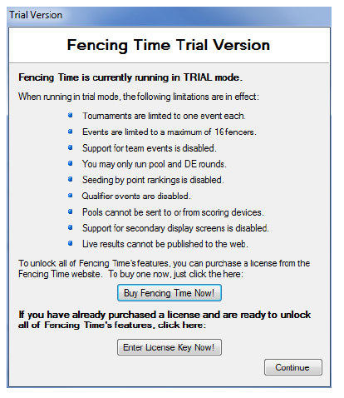
Figure 1 Introductory Screen
- You can continue using the program by clicking on the Continue button. This will allow you to run the program in the restricted trial mode.
- To purchase a licence click on the Buy Fencing Time Now! button. This will take you to the Fencing Time web site and guide you through purchasing a licence.
- If you have purchased a key but not yet licenced the program then click on the Enter Licence Key Now! button. You should then copy and paste the key from the email that has been sent to you and uniquely identifies you as the purchaser of the software. It is very important that you keep the email with the license key so that if you ever need to install Fencing Time on a different computer, you can re-use the key to unlock the full version. You should also be sure to keep your license key secret and not share it with others.

Configuration
The program requires very little initial configuration, the only change that is necessary is to reset the default country. From the Tools menu select Preferences. On the Fencing tab select Great Britain from the drop down list as shown in figure 2.
It is also possible to select a custom logo to be included on all printed output. From the same window select the Prining tab and select the image that you wish to use, it should be no more than 200x100 pixels in size.
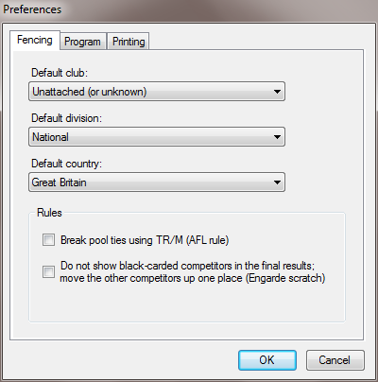
Figure 2: Setting the Default Country
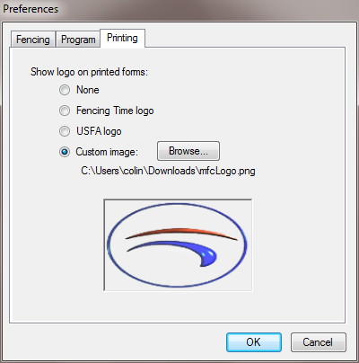
Figure 3: Using a Custom Logo

Customising Displayed and Printed Information
Some default information displayed on the screen or on printed output such as Divisions or Classifications is only relevant to American tournaments. In addition you may wish to limit information shown because it is not appropriate for your tournament or simply because your screen size is limited.
Fencing Time will allow you to customise the content of virtually all displayed and printed information. If one has a screen similar to that shown in figure 4 then the Division and Rating columns are for American tournaments and are not required. You may not wish to have the Born column printed on the check in or competitors sheet. If you press the right mouse button whilst the cursor is on the title bar for the column then you will be presented with a drop down list allowing you to select the columns that you wish to have displayed. After deselecting the Division, Rating and Born windows the above screen now looks like that shown in figure 5.
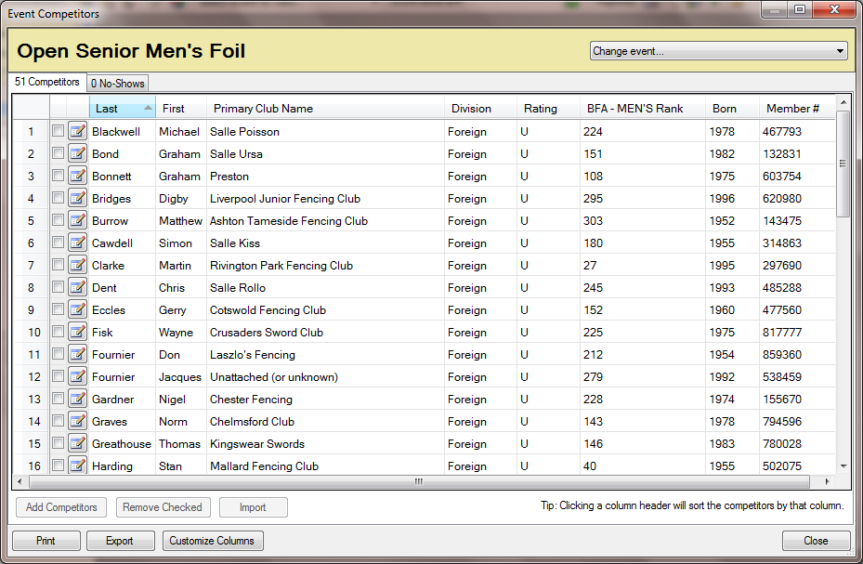
Figure 4: A Typical Uncustomised Window
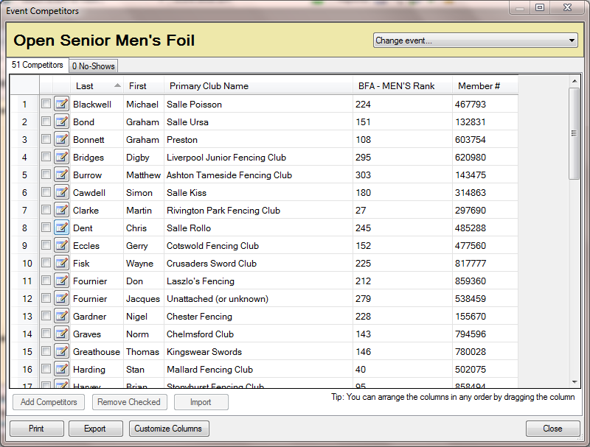
Figure 5: Customised Dialogue Window

Caveats
Fencing Time is a flexible and easy to use program for running tournaments. However the current version of the software is very much geared to the American fencing community and the ranking and competition structure in place there. In most cases this will not be a problem, in places where the user should avoid the default action because it applies specifically to the way American tournaments are run then this will be indicated in the instructions.

The User Interface
The main window for Fencing Time is broken into four parts.
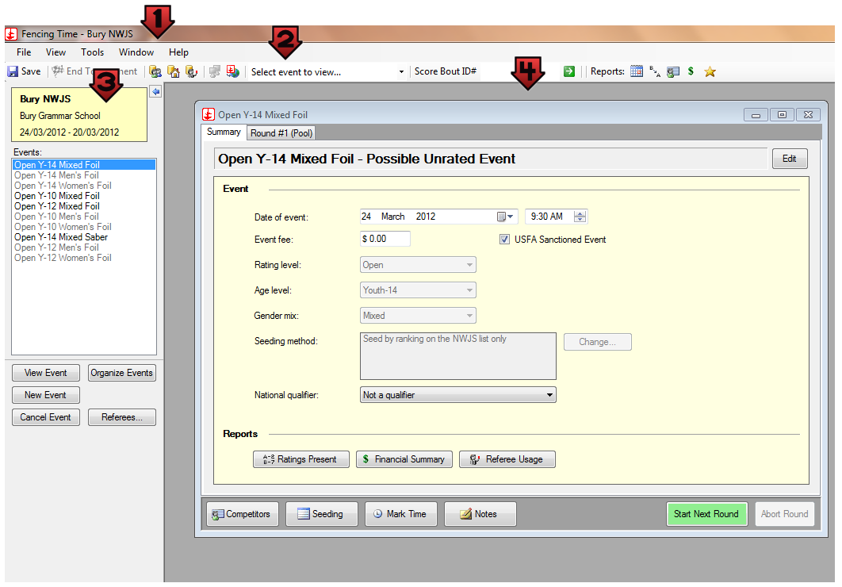
Figure 6: The Fencing Time Main Screen

Main Menu Bar
At the top of the window is a menu bar with the standard drop-down menus that you see in most other programs.
- The File menu provides commands to create new tournaments and access tournament files saved on your disk.
- The View menu provides access to various additional screens in Fencing Time, as well as different reports that summarize tournament information.
- The Tools menu offers a number of helpful commands that you can use to configure Fencing Time.
- The Windows menu lets you organize the event windows you have open.
- The Help menu provides access to various reference materials and guides.

Main Toolbar
The toolbar immediately below the main menu bar provides you with buttons that serve as shortcuts to many functions that are found on the main menu bar, as well as a number of useful ways to quickly enter data into Fencing Time.

Left Side Panel
On the left side of the window is the left side panel. The content of this panel varies depending on whether you are currently running a tournament or not. When no tournament is loaded, the panel will contain buttons that let you create or load tournaments. Once a tournament is loaded (as shown in the picture), the panel will display a list of the events in the tournament and buttons used to control them.
The left menu panel can be hidden from view by clicking the blue arrow button near the top. This will collapse it into a small bar along the left edge of the window. Clicking the arrow again will return the panel to its normal size.

Event windows
The largest part of the Fencing Time screen is area where the event windows are shown. Each event in your tournament appears in its own window here when you choose to view it from the list of events. You can arrange the windows here as you choose.

Preliminaries – Setting up the Database
When running an event the entries are drawn from Fencing Time's database rather than individual entries having to be typed in. While this is an initial overhead it pays dividends in consequent years since it avoids having to re-enter information for fencers as you run new tournaments. There are three parts to the database:
- Clubs
- Fencers, this includes ranking information
- Referees
Entries for each of these parts may be done by importing a CSV file or by typing into a data entry window.

Clubs
Since both fencers and referees will be associated with clubs then it is probably best to set the clubs list up first.

Importing a Club List
From the File menu on the main menu bar use Close to make sure all tournaments are closed. Then from the View menu select Clubs Database. This will produce the window shown in figure 7.
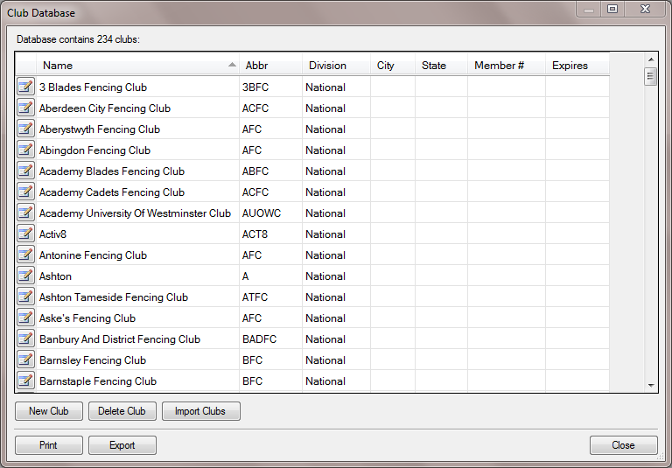
Figure 7: The Clubs Database Main Window
Click on the Import Clubs button, this will produce a window allowing you to select the type of import you wish to make.
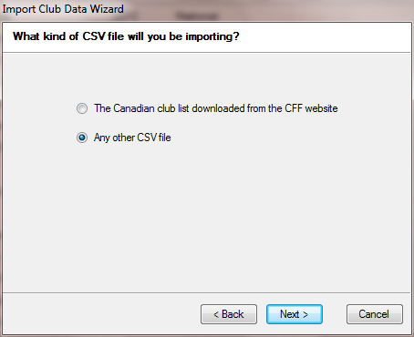
Figure 8: The Clubs Import Window
You should select the Any other CSV file option and click the Next button. This will produce a standard file selection window allowing to to choose the file to import, this should be a CSV file containing, at a minimum, a header giving the name of the entries, and a list of clubs one per line. Optionally each line may also contain an abbreviation separated from the name by a comma.
Name,Abbreviation
West Hill School,WHSFC
Stockport Grammar School,SGSFC
Figure 9: Clubs CSV File Contents
Once the file has been opened you will be presented with a window containing your field headers and what field in the database these correspond to. If you wish to assign a field then double click on the Ignore this column next to it, this will produce a drop down list from which you can select. The only field that you must select is the Club Name. All other fields can be ignored.
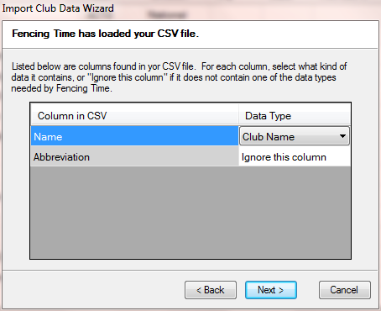
Figure 10: The Club Fields Dialogue Window
Once you have selected the fields then click on the Next button to import the clubs into the database. A log of the actions will be produced, watch for any error messages that indicate one or more clubs have not been imported. These can be added individually as necessary, either as the clubs part of the database is being set up or during the import of fencers for a competition.

Adding Individual Clubs
If there are errors in importing clubs, or only a small number of clubs need to be added to the database then this is most easily done using the New Club function on the clubs database main window. Clicking on this button will produce the data entry window shown in figure 11.
The only fields that you must fill in are the one for the Club name and the Abbreviation. All the other fields are optional and can be safely ignored.

Editing a Club

Figure 11: New and Edit Club Dialogue
If there are errors in the club details then clicking on the edit button on the extreme left of the clubs database main window will produce the New and Edit Club Entry Window shown in figure 11.

Fencers
Adding fencers to the database is very similar to adding clubs. As before make sure all the tournaments are closed by using the Close Tournament menu item from the File menu, then use the Fencer Database item from the View menu to open the fencer database window shown in figure 12.
This window can be used for a variety of tasks, including searching the database for fencers using a variety of criteria, such as surname or membership number. It will also display details of fencers matching those criteria and allow the records for these fencers to be edited.
It also allows the creation of new fencers and bulk operations, such as the import of new fencers and ranking lists.

Importing a List of Fencers
If you are collecting entries for tournaments online then you may have the opportunity to import your data directly into Fencing Time. Export your entries to a CSV file containing at least the following information:
- Forename
- Surname
- Primary club
- Year of birth
- Gender
- BFA number
Where there may be a confusion in forenames, e.g. Matt and Matthew or Tom and Thomas, then you might also consider including a nickname.
A typical CSV file might look like:
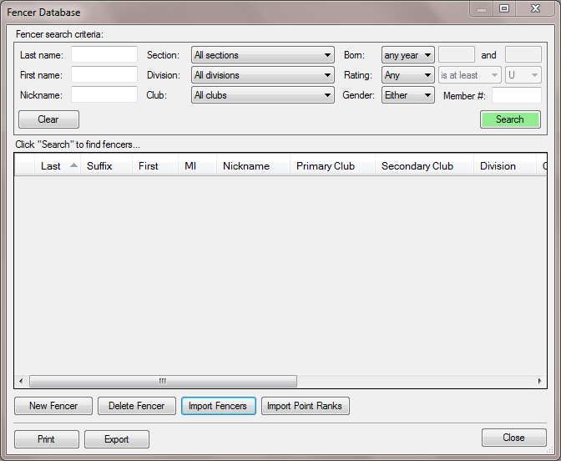
Figure 12: The Main Fencer Database Window
BFA_Number,Forename,Surname,Gender,Year_of_Birth,Primary_club
620476,Alasdair,Adam,M,1991,Northbourne Park School Fencing
850291,Owen,Edwards,M,1994,Wimbledon Fencing Club
599815,David,Croker,M,1993,Dunes Fencing Club
856029,Michael,Taylor,M,1981,Guernsey Fencing Club
558328,Jan,Thomas,F,1956,Newham Swords
388176,Maureen,Edwards,F,1990,Gravesham Fencing Club
Figure 13: A Typical Fencer CSV File
Once you have your CSV file then click on the Import Fencers button which will produce the following screen. You should select the None of the above option and press the Next button.

Figure 14: Importing a List of Fencers
This will produce import the data and prompt you to select which fields in the file correspond to fields in the Fencing Time database. To match a field in the file to a field in the database double-click on the Ignore this column column next to the field you want to associate. This will change to a drop down list from which you can select.
As has been noted above you should enter the forname, surname, primary club, year of birth, gender and BFA number for the fencer. If the fencer is not affiliated to a club then leave this field blank in the CSV file and the affiliation will default to unattached. You should not put unattached in the CSV file.
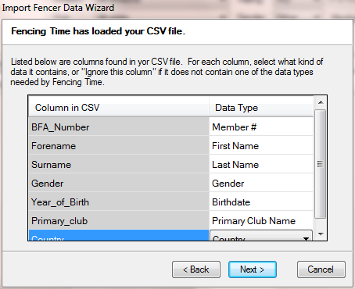
Figure 15: Associating File and Database Fields
Once you have selected all the fields then click on the Next button and your data will be imported. Review the log that is produced to ensure that there are no errors. If some fencers have not been properly imported then these can be added individually or details edited to ensure that they are correct.

Using the BFA Membership Database as the Fencer Database
An alternative to using online entries or preparing your own CSV file would be to use the BFA membership database. This is available on application from BFA Head Office. However the data extract only contains the forename, surname and BFA number. The year of birth, gender and primary club are missing from the extract and need to be added manually.
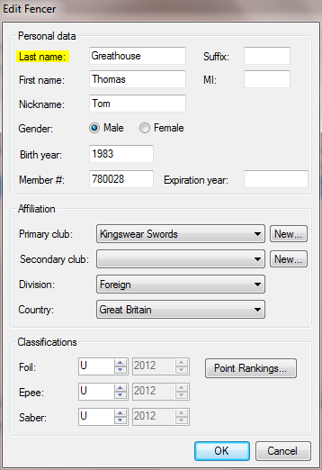
Figure 16: The New and Edit Fencer Dialogue

Adding Individual Fencers
If there are errors when you import a set of fencers, or you are only adding a small number then it is easier to add these using a data entry window. Click on the New Fencer button in the main fencer window shown in figure 12. This will produce the dialogue shown in figure 16.
In the Personal Data panel you should fill in the last and first names and the year of birth if known (this is important for age group competitions since Fencing Time will check to ensure that fencers meet the criterion for the competition). As has been indicated above, where a first name may have an abbreviation then it may well be worthwhile including a nickname. The Membership # field should be filled in with the BFA number, EFC or FIE licence as appropriate.
In the Affiliation panel you should fill in the primary club. If the club is not in the drop down list you can add a new one by clicking on the New button. This will take you to the new club dialogue shown in figure 11. If the new fencer is British then the remainder of the fields can be disregarded. If the new fencer fencer is foreign then you should set the country of origin.
The bottom panel labeled Classifications will be dealt with in the section on rankings.

Rankings
This section forms the major difference between the American and British systems of ranking fencers. Particular attention should be paid to the process of accurately matching fencers to their ranks.
Fencing Time allows you to have multiple ranking lists, you should create one or more appropriate to the kind of tournament you are running. For events which are are mixed (such as age group competitions) you will only need to create a single list. For tournaments which include competitions for athletes of a particular gender then you will need to create a list for each gender.
From the View menu select Point Lists and on the dialogue window select the Custom Point Lists tab. Click on the New List button to create a new list and fill in the details, you must specify the name of the list, an abbreviation and the organisation to which it applies. Selecting an age category will assist in checking whether competitors meet the requirements for the tournament.
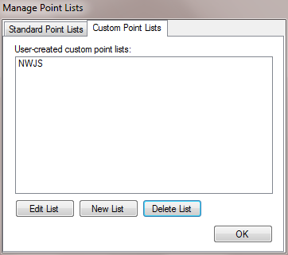
Figure 17: The Point Lists Dialogue

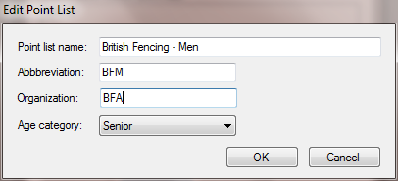
Figure 18: Creating a New Points List

Note that you do not need to create a new list for each weapon since Fencing Time gives each fencer a ranking for all three weapons.

Importing Point Ranks
As with other parts to the database Fencing Time will allow you to import a CSV file. Wherever you get your information from it needs to contain:
- A method of identifying the fencer, ideally this should be the BFA number but Fencing Time will also try to match on the surname, forename and nickname.
- Ranking information. This may either be a position on the ranking table or the number of points the fencer has earned in previous competitions. In general it is best to use the position, but in certain circumstances this may not be possible. For example, figure 19 shows a typical ranking file, as can be seen two entries are for foreign fencers who do not have positions. In this case one would use the points values and end up with a relative rather than absolute ranking.
From the main fencer database window shown in figure 12 select Import Point Ranks. This will give you the usual file browser dialogue enabling you to choose your CSV file. Once you have loaded this then you should select the fields in the usual way, as is shown in figure 20. You must choose sufficient fields to identify the fencer and the ranking. Once you have done this then click on the Next button to import the data. You will be prompted as to whether the list you are importing is complete or partial. You should normally chose Yes, this is the complete point list since this will replace all the ranking points. Choosing the No, this is only a partial point list will only update the fencers in the imported list, other fencers will not have their ranking points changed.
Position,Forename,Surname,Points
1,Bob,Pepper,17452
2,Rich,Curtis,9899
3,David,Appleton,9236
4,Doug,Richmond,8988
5,Peter,Parkinson,8532
NED,Harry,De Kock,8217
6,Pat,Farrell,7834
7,Bill,Ward,7733
8,Paul,Swaffield,7421
9,David,Arthur,7366
10,Arthur,Weightman,7204
CH,Peter,Landrebe,7103
11,Pat,Sinclair,6982
12,Bill,Strang,6719
Figure 19: A Typical Rankings CSV File
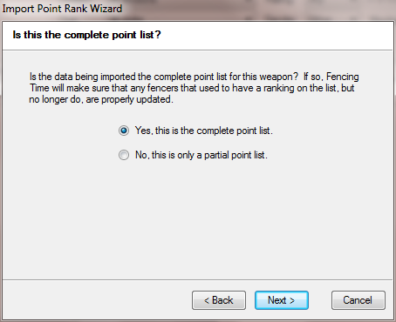
Figure 20: Ranking Import Type
A log will be produced showing the which ranks were accepted and which were not. Where the program is unable to determine which fencer the rank applies to it will leave a gap. This can be amended by hand either before the competition or when it has been started.
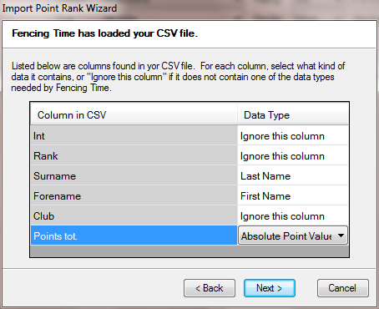
Figure 21: Points List Fields

Referees
Fencing Time also keeps a section of its database for referees. If you plan to allocate referees on a formal basis rather than simply handing score sheets to any available referee then you will need a list of referees to assign.
It is possible to import referees into the database using a CSV file in the same way as fencers or clubs. However unlike fencers or clubs the CSV file has to to be in a specific, and complex, format. Because of this, and because the number of referees will be small compared to the number of fencers it is suggested that the list is generated from the referees dialogue window.
As with the clubs and fencers process ensure that any open tournament is closed by selecting Close Tournament from the File menu and then from the View menu select Referee Database. This will produce the window shown in figure 22.
Click on the New Referee button to produce the window shown in figure 23. You should fill in at least the Last name and First name fields as well as the individual weapon ratings. Where a referee is affiliated with a club you should fill this in, this will assist Fencing Time to avoid allocating referees to poules or direct elimination bouts where there could be a possible conflict because of a fencer and a referee coming from the same club.
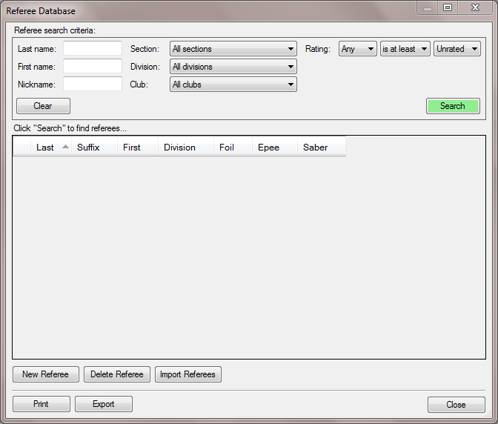
Figure 22: Main Referee Screen
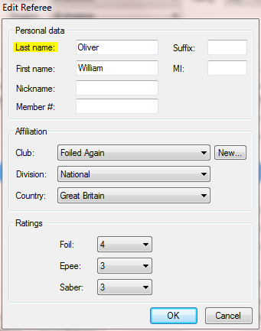
Figure 23: The New and Edit Referee Screen
Once you have filled the details in then press the OK button to save the details.

Planning the Tournament
There are a number of things that need to be taken into account when planning a tournament, these include
- Venue – you will need to ensure that it has sufficient space for the number of people who will attend, including car parking space. Its location is also a consideration, if it is difficult to get to then this may put possible competitors off. If you are running a tournament in a location which is not permanently open, such as a school, then you will need to ensure that someone is available to open the venue in good time both for laying of pistes and on the days of the tournament.
- Availability of accommodation – though you may not be responsible for accommodation a venue which has good, local hotels and boarding houses will make your tournament more attractive.
- Catering – fencing tournaments are all day affairs. If your tournament is in a venue which does not have catering then you should either make this known when you advertise the tournament, consider employing outside caterers or getting volunteers from your club to provide catering. When you consider the number of fencers and those accompanying them this can make a good contribution to the overall profit.
- Equipment – you will obviously need scoring equipment for each piste plus some spares. For larger competitions sponsored by equipment vendors then this may not be a problem, but for smaller tournaments you may have to borrow from local clubs if your own club does not have sufficient equipment. Remember that you will need to put scoring boxes on tables. You should also consider whether conductive pistes are necessary, whether they should be used throughout the tournament and just for the finals.
- Marketing – it used to be the case that all one needed to do to market a tournament was to place an advertisement in The Sword which included an entry form. These days most tournaments of any size will either have a dedicated web site or a section on a club web site, often with the ability to do online entry. Web sites for tournaments should also include details of the programme, location of the venue with directions (Google Maps is ideal for this), tournament contacts and possibly a downloadable entry form. Other things that add interest are results from previous years, photo galleries and links to social media such as Facebook and Twitter.
- Entry forms – if you do have a web site for a tournament then you may consider online entry. There are a number of event registration applications for standard website software, writing a registration application is a major undertaking and should not be undertaken by anyone without a great deal of software development experience. Regardless of whether you use an online entry system or paper entry then you should determine what information you need to collect, you should not collect more information than is necessary. The following is fairly typical:
  - Identification information, this should include forename and surname as well as appropriate licence details
  - Contact information, this shold include phone numbers (land line and mobile) and email address. This is required in order to inform competitors of any changes to schedules
  - Competition information, this may include the weapon, gender and age group
- Safety – fencing is a safe sport and accidents are rare. For a large tournament you may wish to consider using an emergency first aid organisation such as St. John's Ambulance if the venue does not provide dedicated first aiders. A risk assessment of the premises may be a useful exercise.
A major constraint in all of this is of course your budget! Something that will not be considered further in this document.

Timing and Piste Usage
You will almost certainly not be able to provide enough pistes to run all your events simultaneously. You will therefore need to ensure that all your pistes have the highest possible usage. To assist you in doing this table 1 gives some rule of thumb estimates for the time to run a round.
You should allow additional time for the following:
 | Foil | Épée | Sabre
Poule of 6 | 1.5 hours | 1.5 hours | 1 hour
Poule of 7 | 2 hours | 2 hours | 1.5 hours
DE Match (15 hits) | 15 minutes | 15 minutes | 10 minutes
Team match | 1 hour | 1 hour | 45 minutes
Table 1: Estimates for Running a Round
- From check in closing until the start of the competition
- From the end of the poule round to the start of the DE
- Between each phase of the DE
In each case a minimum of 30 minutes should be allowed.
Besides maximising the use of pistes you should also aim to minimise the amount of time that fencers have to wait between rounds, this is especially true for incomplete tableaux where some fencers will have byes.
A simple tool for planning piste usage is a spreadsheet, a typical example is shown in figure 24. The one disadvantage is that it is static, which makes it difficult to track which pistes are in use, which fights are allocated to which pistes, what time scoresheets went out and whether they have been returned or not. A large whiteboard with the tournament plan on it can help with this.
Another alternative, for those with the experience and the software, would be a project planning application such as Microsoft Project.

Referees
The type of plan outlined above depends not just on the number of pistes you have, but the number of referees as well. It is of no use to schedule a round on eight pistes when you only have four referees. You obviously need to make best use of your referees without overworking them.
If you have a number of referees then you will need to coordinate their usage with the DT. This will mean designating one of them as a lead referee and ensuring that you have a helper who can pass information on referee allocation to the DT.

Helpers

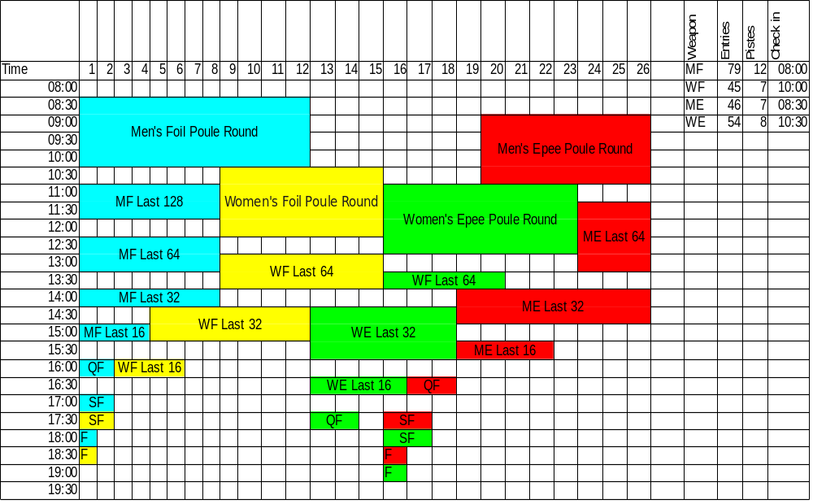
Figure 24: Tournament Planning Sheet
Tracking the running of the tournament is the key to success. If you know exactly what is going on at all times then you can ensure that any problems are dealt with immediately and not allowed to escalate.
You will need a group of volunteers who are allocated specific tasks, these include:
- Check in desk – ideally one person who will check people off on the list and a second to take any outstanding entry fees. If you have multiple competitions checking in at the same time then you should have one person per check in list if possible.
- Runners – to liaise between the DT, referees and floor managers.
- Referees' assistants – to liaise between the DT and referees
- Floor managers – to ensure that the equipment is working properly and also to make sure that bouts that are supposed to be running are actually running
- Welfare staff

Armourers
For larger tournaments armoury services may be supplied by the equipment vendor who is attending the event. For smaller events you will need to provide at least sufficient armourer involvement to make sure that pistes are running properly.

Directiore Technique
The DT is a vital part of any tournament, however small. You should ensure that you use the most experienced people you can find.
The role of the DT varies with the size of the tournament. For a large tournament its principle role is to manage fencing related matters, rather than the operational side of the tournament. For smaller competitions the two roles may be combined.
However, you should ensure that there are sufficient members of the DT available to resolve any issues and disputes without effecting the smooth running of the tournament.
Some of the tasks carried out by the DT will include:
- Agreeing the formula for the tournament with the competition organiser, this will include the number of rounds of poules, whether there should be a cut after the poules, whether repechage should take place etc.
- Agreeing the timetable, including the number of pistes and allocation of referees.
- Deciding on any re-drawing of the poules in response to a successful appeal.
- Resolving any dispute in written paperwork (incorrect score sheets).
- Deciding on the course of action to be taken in response to a fencer scratching or being excluded.
This is a non-exhaustive list, other tasks will almost certainly be required.

Before the Tournament

Creating the Tournament
To create the tournament, with all previous tournaments closed click the New Tournament button on the left panel shown in in figure 25.
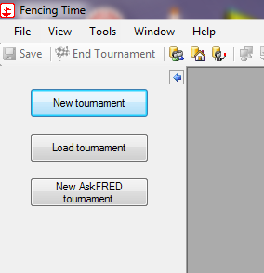
Figure 25: Creating a New Tournament
This will bring up the Edit Tournament window shown in figure 26, fill in the name of the tournament, its location and the dates on which it will take place. Unless you are going to charge to actually register for the tournament then ignore the Registration fee box, a later screen will allow you to set an entry fee. Click on the Next button, this will take you to the initial screen of the Event Wizard, where you will be taken through a series of screens to set up the first event of the tournament.
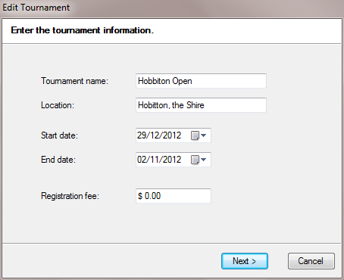
Figure 26: Tournament Details

The New Event Wizard
This Wizard is used not only to create the first event of a tournament, but all other competitions that make up the tournament as well.
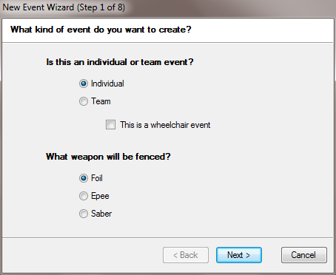
Figure 27: Event Type and Weapon

The initial screen is shown in figure 27, fill in the type of competition (individual or team) and the weapon that is to be fenced (foil, épée or sabre) and press the Next button.

Date, Time and Cost
Once you have have defined the type of competition you need to specify when it will take place and what the entry fee is. This is done in the window shown in figure 28.

Gender, Age and Classification
The next three screens allow you set the gender, age and classification of the fencers taking part in the tournament. The first two (figures are appropriate for competitions in Britain. You should be aware though that direct elimination bout for the youth age groups are fenced as three poule bouts rather than as a single bout with a smaller number of hits.
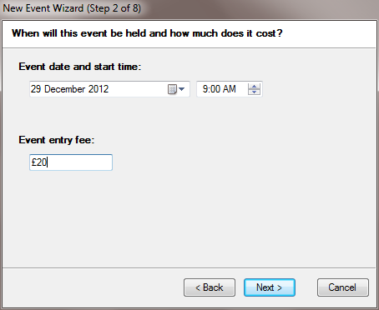
Figure 28: Setting the Date and Time
The final screen in this series allows you to select the classification of fencers for the event, this is purely for American tournaments and you should always select None.
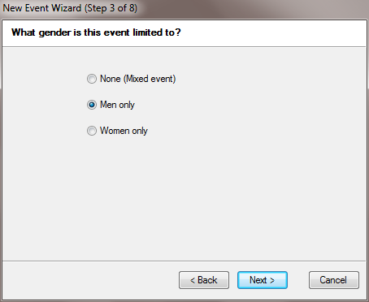
Figure 29: Selecting the Gender
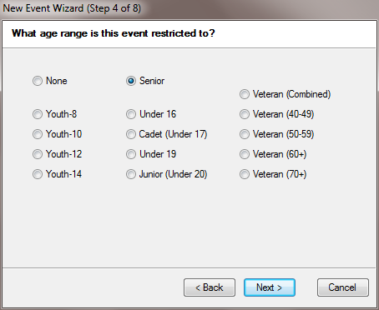
Figure 30: Selecting the Age Group

Seeding
This part of the event wizard needs particular attention since the default is to use the American rating system which is quite different to the system used in the UK.
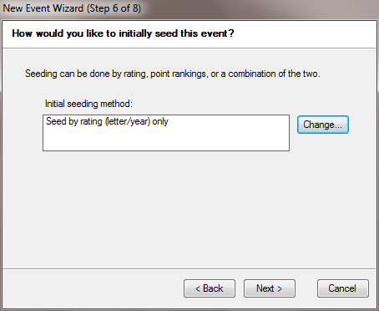
Figure 32: Choosing the Ranking Method
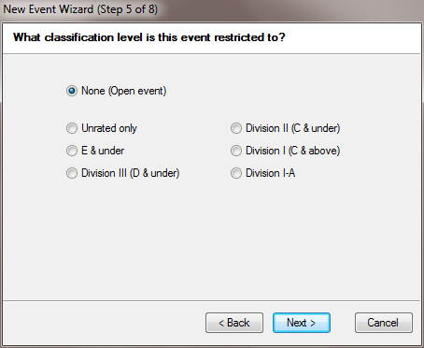
Figure 31: Selecting the Classification
When you are prompted to use the default seeding method shown in figure 32 you should click the Change button. This will produce a new window (figure 33) on which you should choose to rank fencers on a points list only.
On the next screen (figure 34) you should select the points list for the tournament.
Once you have clicked the Next button you will get the confirmatory screen shown in figure 35.

Clicking on the Finish button will almost complete setting the tournament ranking scheme. You will be again prompted for the initial ranking scheme shown in figure 32, but this time with the method that you have chosen for ranking. Click on the Next button to complete the Event Wizard.
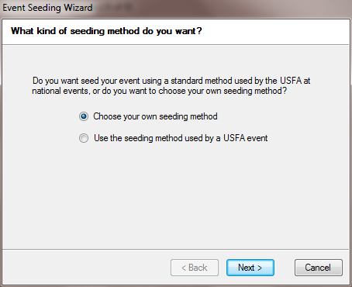
Figure 33: Ranking from a Points List
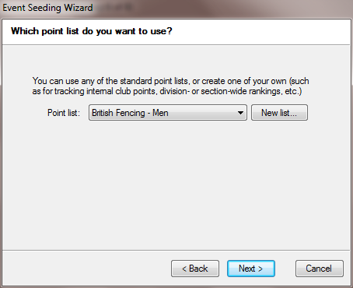
Figure 34: Choosing the Points List
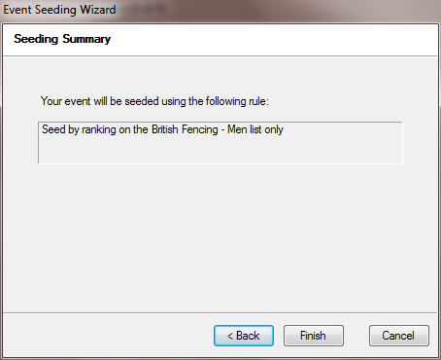
Figure 35: Confirming the Seeding Method
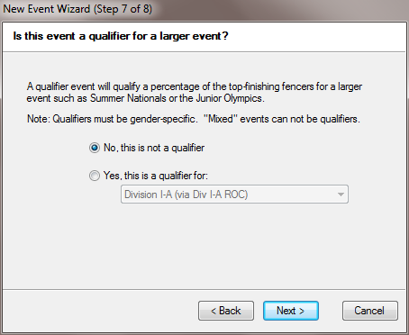
Figure 37: Choosing the Qualification Type
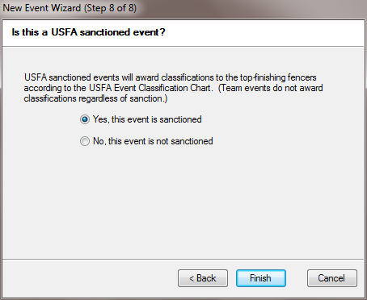
Figure 36: Selecting USFA Sanction

Completing the Event Wizard

The final two steps of the Event Wizard are only applicable to American tournaments. When prompted as to whether the event is a qualifier then you should select the No, this is a not a qualifier option, and the Yes, this event is sanctioned option should be chosen for the sanction type.
Clicking on the Finish button will complete the wizard for this event and will take you to the main tournament screen shown in figure 38. If you have further events to add to the tournament then you can repeat the Event Wizard for these by clicking on New Event on the left hand panel of the screen.
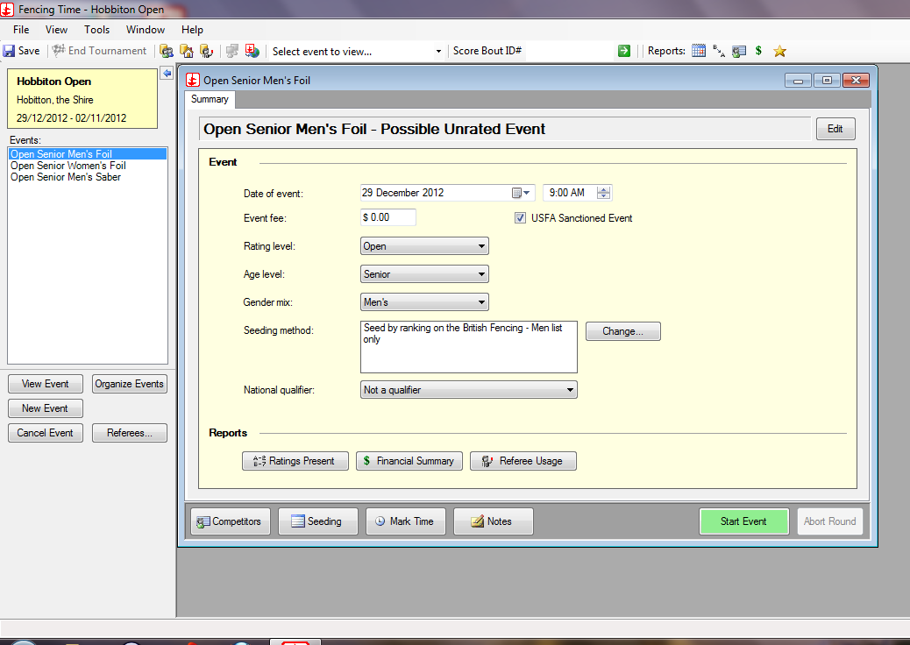
Figure 38: The Main Competition Window

Adding Competitors
At this point you should now have all your competitions set up. You should also have a database that contains all the fencers who will be taking part in your tournament (page 12). You may also have a list of up to date rankings (page 16), though this may be done later. What you have not yet done is selected the fencers from the database who will be fencing in each competition.
There are two ways of doing this, either by searching the database for matching records or by importing a CSV file, the latter is the easiest option and will be dealt with first.

Importing Entries
If you have used an online entry system and it can export CSV files then the easiest way of registering fencers for competitions is to import the CSV file. An example of such a file is shown in figure 39.
The only thing that the file must contain is a method of identifying the fencers, Fencing Time will match on surname, forename and nickname. These will be standard for registration applications but may not be unique, if you can include the BFA number, in your registration form then this does provide a unique key for matching fencers.
DT UserId,firstname,lastname,BFA_Number,Club,Age_Group,Country
"595","Alexander","Davis","974696","Team Newcastle","Senior","GBR"
"587","Jake","Drummer","871282","Leeds Met","Senior","GBR"
"580","Edward","Castle","942979","Regent Fencing","Senior","JER"
"569","Duncan","James","322157","Pembroke Fencing Club","Veteran","IRL"
"561","Daniel","Jones","526588","Newcastle University","Senior","GBR"
"560","Simon","Marshall","725127","Kiveton Park","Veteran","GBR"
"554","Ian","Tickle","984176","Foiled Again","Veteran","GBR"
"549","Liam","McAndrew","428765","Salle Paul","Senior","GBR"
"548","Alex","Bryant","871094","Leeds Fencing Club","Senior","GBR"
"547","Peter","Williams","743697","Leeds University","Senior","GBR"
"546","David","Rodgers","239812","RLS","Veteran","GBR"
"545","Tom","Hughes","873194","University of Leeds","Senior","GBR"
Figure 39: Export from an Online Entry Application
Click on the Competitors button on the main competition screen (figure 38) with the appropriate competition selected from the left hand panel of the screen. This will give you the screen shown in figure 40.
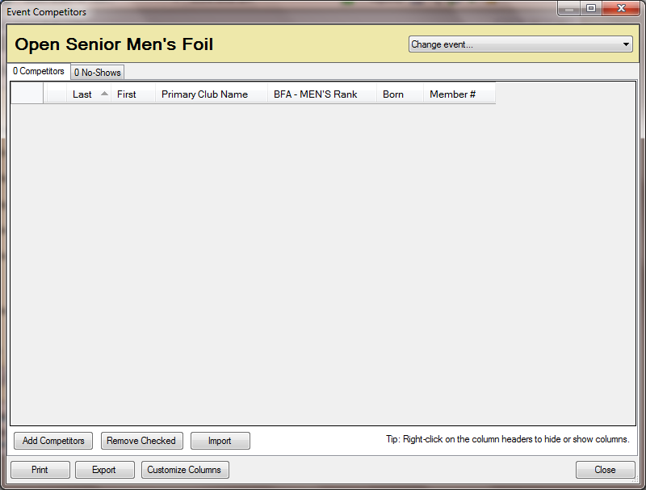
Figure 40: Initial Competitors Screen
You can now click on the Import button to import from your CSV file. As before you will be prompted to enter the name of the CSV file, once you have specified this then you need to identify the fields in the file and match them to those Fencing Time uses. For the file shown in figure 39 the fields are matched as shown below (figure 41).
Once the data is imported the window should now contain the competitors for the tournament (figure 42).
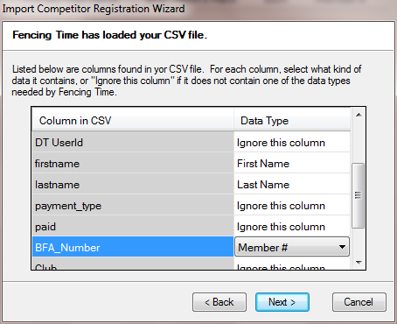
Figure 41: Matching Entry Data
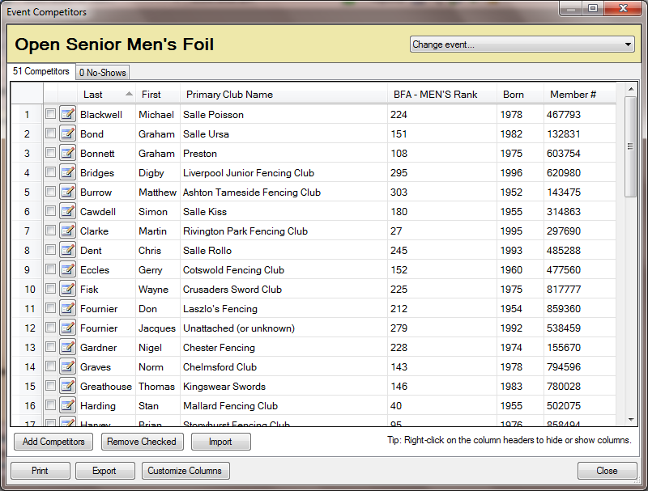
Figure 42: Imported List of Competitors
As the data is imported a log will be produced showing any errors during the import process. If the imported data is in conflict with the database (e.g. different club affiliations in the two sources, or different years of birth) then you will be prompted to say which version is correct.
Even if there are no errors during the import you should not assume that the data is correct. You must validate the entries before starting the competition. This is dealt with in the section on validation (page ).

Entering Competitors from the Fencer Search Form
If you only have a small number of fencers to add to the competition then you can use the search form (figure 12). You can search by a variety of criteria though the Last name and Member # (BFA Number) will probably be the most common. To get to the search form click on Add Competitors on the Competitors Screen (figure 40). Enter your search criterial and click the Search button. If the

Validating the Entry List

Checking Against the BFA Membership Database

Starting the Tournament

Check In List
Before the tournament starts you must provide the people on the check in desk with a list of people who have entered together with information that may require to be checked or changed (e.g. BFA number, club affiliation or country, whether the fencer has paid or not).
You will be running the tournament with Fencing Time, you should not use alternative sources of data since these may be incompatible with that held by Fencing Time.
To print the check in list adjust the list of fields you wish to have on the list by clicking on the right mouse button while the pointer is in the title bar on the list of competitors (figure 42), then press the Print button.

Processing the Check In List
The people on the check in desk must make sure that when they mark the check in sheet they do so with absolute clarity. However you can assist them by making the sheet as easy as possible to use:
- When you are setting up the list of fields make sure you include the Here box. You should also have an understanding of what goes in the box. It is suggested that rather than ticks or crosses, which can be confused, you use P and S for “present” and “scratched” respectively. If the check out time has expired and a fencer has not checked in the mark the box A for “absent”. Do not leave any of the boxes empty since this is ambiguous.
- If the desk has to collect money from fencers then include the Paid field. Since it is not possible to import this from a CSV file and the numbers who have not paid is likely to be small it is suggested that you only set the amount in the field of fencers who have yet to pay.
- If membership numbers have been checked in advance and only a few are outstanding then include the fact that particular fencers need to be checked in the Registration notes field.
Once the check in has closed an announcement should be made giving the list of fencers who have not checked in (marked “absent”) and a limited amount of time to present themselves. After this the list should be processed.
- Fencers who are absent or scratched should be removed from the list of competitors. This is done by clicking on the check box on the list of fencers (figure 42) and, once all the absent fencers have been ticked, then clicking on the Remove Checked button.
- You should any additional fencers who been allowed a late entry by the check in desk. Ensure that their seeding is correct either from the database or from the current ranking lists.
- You should alter any club affiliations noted by the check in desk, this is done by clicking on the edit button (the icon with the pencil next to each fencer in figure 42), this will take you to the edit fencer dialogue (figure 16)
- If the check in desk have collected any missing BFA numbers then you should also associate these with the approriate fencer, these will then go into the database for the next tournament.
- Finally you should ensure that the number of fencers present in the check in list is the same as that in the list of competitors.

Starting the Event
Once you have corrected any errors and omissions you can start the event. Click on the Start Event button on the main competition screen (figure 38) and you will be presented with the initial seeding window shown in figure 43.
You should rarely need to alter this since you already have the seedings in the database, however if you do need to make modifications then checking the Allow unrestricted manual seeding will allow you to use the arrows at the side of the window to move fencers up or down the list.
You should publish the list of fencers in at least two places in the hall and announce that this has been done. You should allow a few minutes for them to check that they are on the list, have the correct affiliation and ranking.
Once you are satisfied with the list then click on the OK button to start the first round.
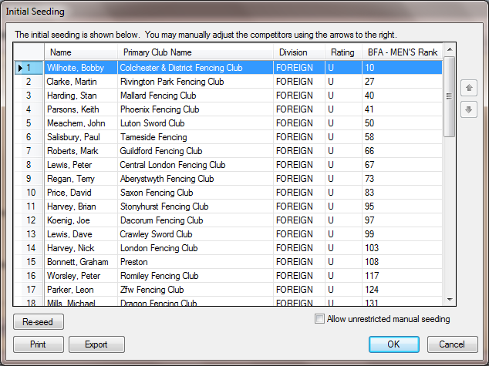
Figure 43: Initial Seedings at the Event Start

Poule Rounds

Creating the Poules
At the start of a round you will be presented with the screen shown in figure 44, you should select the Pools option and click the OK button.
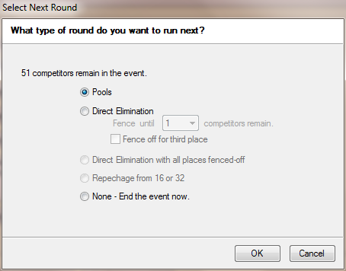
Figure 44: Select the Round Type - Poules
If this is the first round of poules the next screen (figure 45) will give you options for the number of poule and their sizes.
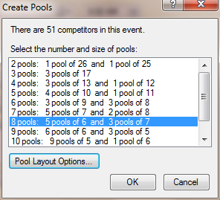
Figure 45: Selecting the Number of Poules
Normally you should attempt to run with poules of 6 or 7 in size. When you click on the OK button you will be given a screen which gives you the composition of the poules.
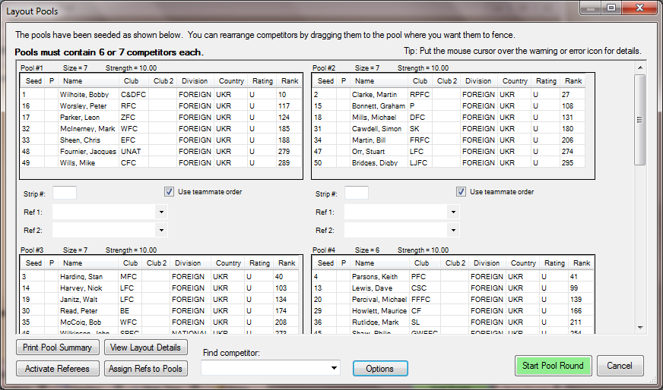
Figure 46: Poule Allocations
Fencing Time will attempt to produce poules which:
- minimise conflicts, e.g. too many or too few competitors from a particular club in a poule or fencers with the same surname in the same poule.
- Have approximately the same strength based upon the rankings.
If this is not possible then a warning icon will be shown.
You can move fencers between poules by simply dragging from one poule and dropping them in another. Alternatively right-clicking on the surname, this will show the screen in figure 47. You can either move the fencer to another poule or swap them with a fencer in another poule. To do the former simply select the poule from the drop down list and press the OK button, to do the latter select the poule which contains the fencer you wish to swap with and then the fencer and click OK.
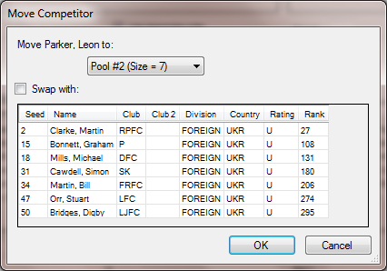
Figure 47: Moving or Swapping a Fencer Between Poules

Entering Piste Numbers
Once you are satisfied with the poule layout then you can enter the piste numbers. On the poule allocations screen (figure 46) simply type in the number into the Strip # entry field. Once you have done this you can print a cFinally click on the Start Pool Round button to show the poule information (figure 48).

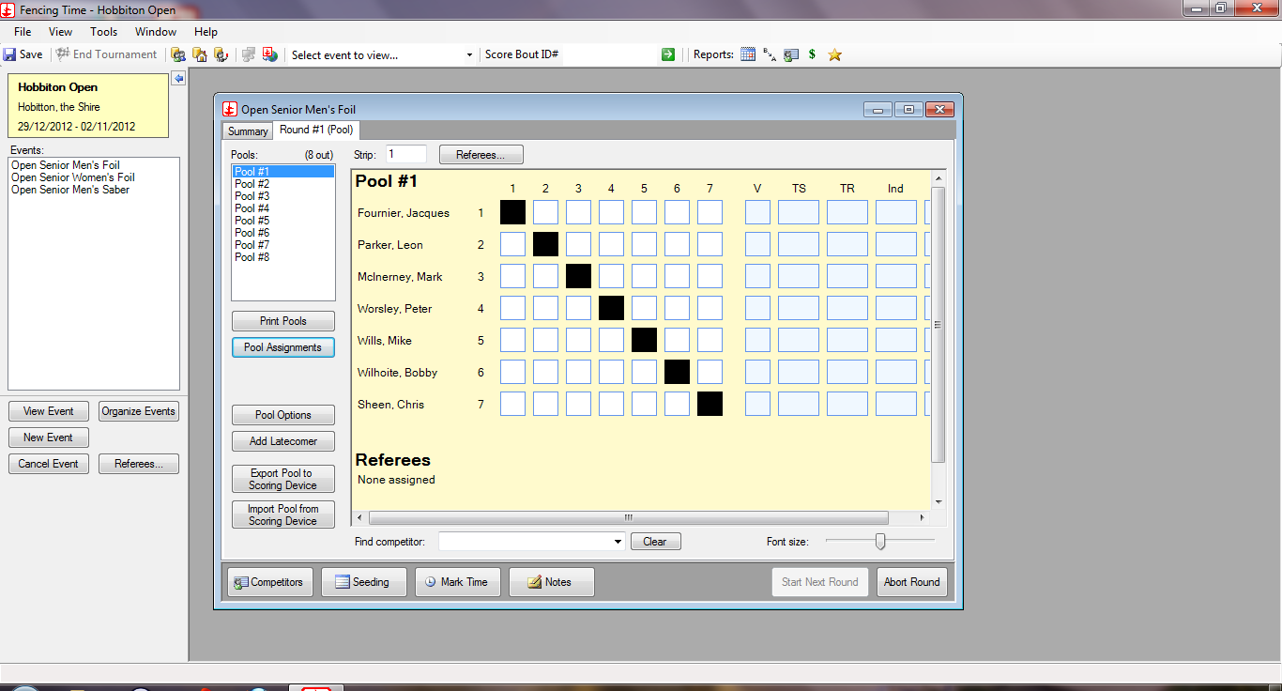Figure 48: The Main Poule Screen

Announcing the Poules
Once you have created the poules you can print an alphabetical list of fencers and piste assignments by clicking on the Pool Assignments button and selecting the Competitor order tab.
These sheets can be pinned up in at least two different locations and an announcement made that this has been done. This is much more efficient than attempting to read the assignments out over a PA system or by standing in the middle of the hall and shouting.
You should allow a few minutes for people to check the assignments and come to the DT if they have not been included.
You can then print the poule sheets by clicking on the Print Pools button.

Adding a Late Comer to the Poules
Fencing Time will allow a late comer to be added to a poule. On the poule information screen (figure 48) select the poule to which you want add the fencer and click on Add Latecomer. This will give you the standard fencer search screen (figure 12), here you can search for a fencer by name, membership number or other criteria. Select the fencer by clicking on the check box and then the Add Checked button. Once you have done this you will need to reprint the poule sheet.

Redrawing the Pools
At international level the practice is not to redraw the poules regardless of whether a mistake has been made. However FIE competitions are much more regulated than domestic competitions and you may have to make waive this unwritten rule, especially if the mistake was made by the DT.

Fencer Left out of the Pools
If you have left a fencer out of the poules then you must add the fencer to the competition. This can be done using the same process as adding a late come (page 38). If you have poules of 6 and 7 then you should add the fencer to a poule of 6 which does not lead to a poule with a significantly different strength to the other poules.
If you only have poules of 7 then you will have to redraw.
If the fencer who was left out has a significant ranking (e.g. you omitted the number 2 seed) then it will almost certainly prove impossible to place the fencer in a poule without unbalancing the strength of the poules. In this case you should redraw the poules.

Fencer Included Who is Absent
If you have included a fencer who is absent then the action you take should depends on which poule they were in and the ranking of the fencer. The basic principle is to ensure fairness to other fencers in the competition.
If you have mixed poules of 6 and 7 and the fencer was in a poule of 7 and had a low rank then you can safely remove them from the poule and reprint the poule sheet.
If the fencer was in a poule of 6 or had a high rank then you should consider a redraw.

Incorrect Draw due to Ranking
If you have correctly ranked the fencers in the competition then you should not redraw.
If you have made a mistake in the rankings then you should only consider a redraw if there is a significant difference between the ones you have used and the published ones.
You should include the rankings on the list of fencers that you display in the hall.
Note that if you have used ranking points to seed the fencers and the positions include one or more foreign fencer then fencers below the foreign fencers will be pushed down in position, though the relative positions will remain the same. You may need to explain this to fencers who wish to know why their position is not the same as on the ranking list.

Incorrect Draw due to Affiliation
If the fencer has not provided the correct affiliation details when entering the tournament or during check in then the draw should stand.
You may have to explain why you have modified the fencer's affiliation, e.g. some fencers may have entered using a full club name while others have used initials and you have regularised the entries.
If you have made a mistake then you should redraw only if it makes a significant difference to the competition.

Entering the Results of the Pools
As the poule sheets are returned you can enter the results by selecting the poule from the left hand panel of the main poule screen (figure 48). Click in the first empty box on the top line and type the value from the poule sheet. As you type the number Fencing Time will automatically move you to the next box, there is no need to press the return key to move to the next line.
If you have a bout that has gone to time and not reached the full score then simply type the number of hits, Fencing Time will work out whether, for example a “3” is a win or a loss. Once you have completed the sheet then the indicators will be calculated automatically, as shown in figure 49.
If a fencer has not been able to complete all their fights you should withdraw them, none of their results will then be counted. Click on the Withdraw/Exclude button and select the fencer to withdraw. If the fencer failed to complete the poule because of medical reasons then you should withdraw them, if they have been black carded then you should exclude them.

You should validate that the entries on the screen match those on the poule sheet. To avoid simply scanning the sheets it is recommended that you read the entries downwards instead of across. Once you have validated the results then mark the printed sheet in some way to show that it has been processed. You do not need to note the time on the sheet since Fencing Time keeps timestamps for significant events, of which the completion of the poule sheet is one.
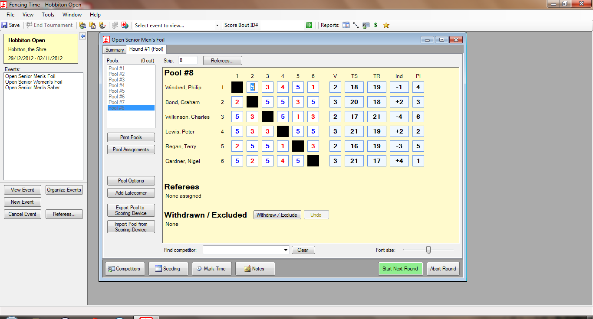
Figure 49: A Completed Poule Sheet

Errors on the Poule Sheet
During data entry Fencing Time may produce a warning message informing you that there is an error on the score, usually two fencers being credited with a victory or with equal scores in a particular match. The first thing you should do is to make sure that you have entered the data correctly from the boxes on the sheet. If you have done so then check the score for the match on the bottom of the sheet.
If you still cannot reconcile the scores then this almost certainly means that there has been more than one transposition. Enter the remainder of the data, this will allow you to determine how many fencers (and referees) you need to call to the DT.

Printing the Results of the Pools
Once the poules have been completed you should print copies which can be displayed for fencers to check. You should allow a specific amount of time for this to happen before proceeding to the next round of the tournament.
If there are any disputes then you should initially check whether a mistake was made during data input. If it was then this can be corrected on the poule entry window (figure 49) for the appropriate poule. If it was not then both fencers should be brought to the DT to resolve the issue. If it cannot be resolved then the result should be allowed to stand.

Abandoning After the Pools, but Before the Direct Elimination
If a fencer tells you they wish to abandon after completing their poule fights then there are two possible alternatives:
- If they abandon after the poules then Fencing Time will mark them as DNF (Did Not Fence) and place them last in the rankings.
- If they proceed to the direct elimination round and then tell their opponent and assigned referee that they wish to withdraw then Fencing Time will award the bout to their opponent but they will retain their position in the final ranking table as though they had lost the bout.
You should explain the position to the two scenarios to the fencer.
If they do not wish to be included in the DE then you should select the poule that they were in and click on the Withdraw/Exclude button, select their name and withdraw them.
If they wish to take the second option then draw the DE and advise the fencer's opponent of the situation and that he or she has a bye. Strictly the fencer should present themselves at the piste, but there is no actual need to do so.

Withdraw or Exclude
Fencing Time has two alternatives for eliminating a fencer from a tournament:
- Withdraw (or abandon) is used when the fencer is unable to continue for medical or other reasons
- Exclude is when the fencer receives a black card
In the case of the poules Fencing Time will retain the fencer in the ranking list but place them last, marking them as DNF (Did Not Fence). If they are excluded then an entry will be placed last in the ranking list, but the name will appear as Fencer Excluded.
The situation is slightly different in the DE. In both cases the fencer effectively loses the fight and their opponent wins, the result of the bout will be used in the calculation of the final rankings. If the fencer has withdrawn then they will be credited with their position in the rankings, if they were excluded then their name will replaced by Fencer Excluded in the ranking list.

Ranking After the Poules
Once the poules are finished and any challenges to them have been reconciled then you can print the ranking list. This can be done either by clicking the Start Next Round button or using the Turn DE Wizard once the tableau has been generated. Using the former will show the dialogue window illustrated in figure 50. Clicking on the Print button will print the ranking list which you should display with the rest of the paperwork for the event.
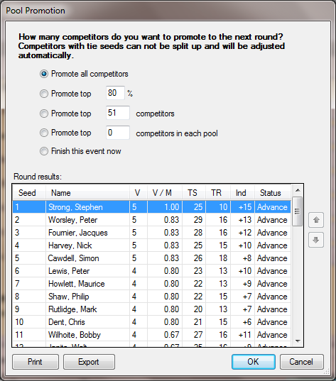
Figure 50: Ranking After the Poules

Direct Elimination
Once you have printed the ranking list and decided on how many fencers you wish to promote to the next round you should click on the OK button. This will prompt you as to what kind of round you want, either a poule round or a direct elimination round. Select Direct Elimination as shown in figure 52 and the tableau will be created automatically.
Note that you will also be asked whether you wish to save the tournament at this point (figure 51), whenever this window appears you should always respond in the affirmative. This will allow you to correct any mistakes that you inadvertantly make.
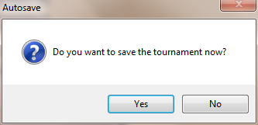
Figure 51: Saving the Tournament
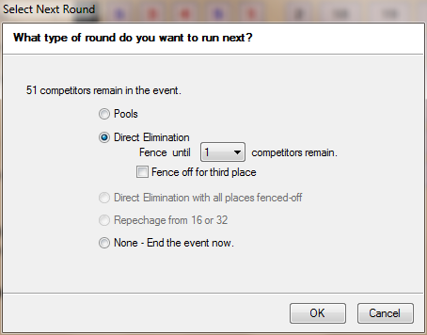
Figure 52: Selecting a Direct Elimination Round

Entering Piste Numbers and Times
A typical tableau is shown in figure 53.
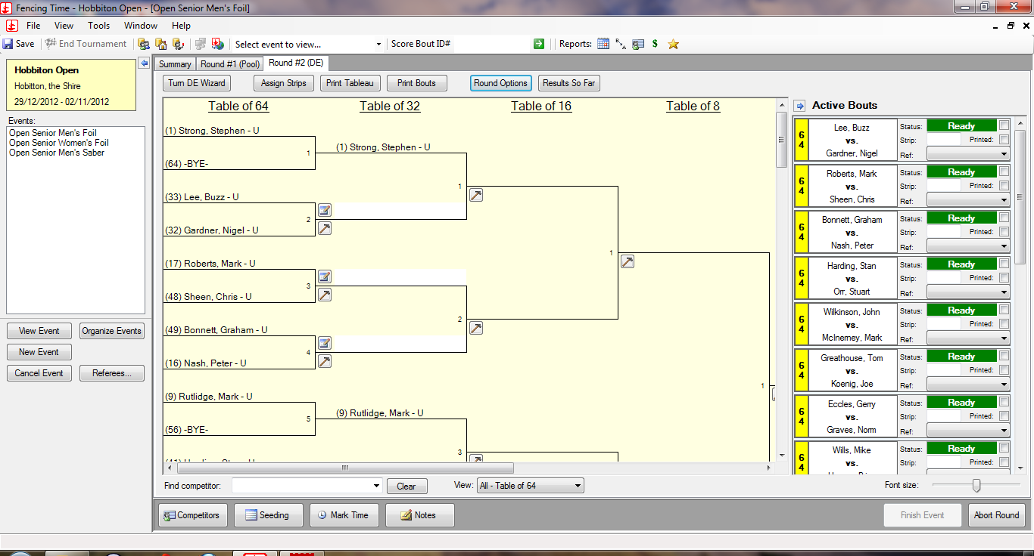
Figure 53: The Initial Direct Elimination Tableau
Next to each bout are two icons, one above the line and one below. Clicking on the icon below the line (the one that looks like a hammer) will allow you to enter the piste number and the time for the bout, as shown in figure 54.
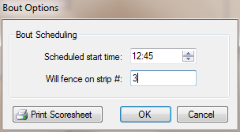
Figure 54: Setting the DE Piste and Time
You should set the times and pistes for at least the current round. If you are confident about the timing of the competition then you can also set the information for subsequent rounds based on the timing estimates in table 1.

The Turn DE Wizard
The easiest way to print the tableau and other information is to use the Turn DE Wizard button. This will give the dialogue shown in figure 56.

Check the boxes for the information that you require printed. The items in steps 2 and 4 are the most likely for an average tournament while those in step 3 will be used for larger tournaments with a more formal assignment of referees.

Printing the Score Sheets
If you do not use the turn DE wizard then score sheets for matches can be printed by clicking on the Print Bouts button in the tool bar for the tableau (figure 53). This will present you with the dialogue window shown in figure 57. If you are running your competition round by round, e.g all of the last 64 matches, then all of the last 32 matches then ensure that you deselect the option to print bouts where only one competitor has been determined.Entering the Results
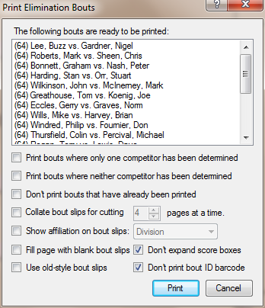
Figure 55: Printing DE Score Sheets

Entering the Results
There are three principle ways of selecting a match to score:
- Click on the icon above the line next to the match
- Double click on the match in the Active Bouts panel to the right hand side of the tableau
- Enter the bout id printed on the scoresheet in the Score bout ID and press the return key
In each case you will be presented with a scoring box shown in figure 56.
Simply enter the scores and click on the OK button. The tableau will be updated and if the scoring of this match means that another match can be scheduled it will be added to the list of active bouts.
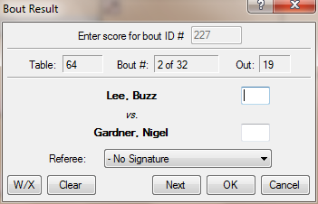
Figure 56: Scoring a DE Bout

Alternative Methods of Running the DE

The Single Tableau Method
This is the method described above, you send out the score sheets for a particular phase of the DE (e.g. last 64) at the same time and do not start any more matches until all the score sheets have been returned.
The advantages of this is that it is easy to understand where you have reached and how long it should take to complete, it also saves on confustion as to which matches are actually out.
The disadvantage is that a hold-up one one piste can cause the rest of the tournament to be delayed. Inevitably this will occur at a phase of the competition where you are running four fights on this piste and recovery will then be difficult.

Continuous Fencing
In this method you issue scoresheets as soon as there are matches in which the two fencers are determined. You can use this method if:
- You try to ensure that the same piste is used for the next match in the tableau, so that the winning fencer does not have to move. This may not always be possible, you may have winning fencers from two pistes.
- You have a good PA system, or have instructed the winning fencers to remain by the piste on the completion of their matches
- You have briefed the referees to return each match as soon as it is complete or, better, ensure that your runners move from piste to piste collecting scoresheets.
You must allow fencers time after the completion of a bout before they start the next one. Fencing Time can assist in this since it will time down from the ten minutes allowed once the scoresheet has been returned.
While this gets around the problem of a single piste holding up proceedings and a hiatus while a phase of the DE is scored it can be chaotic, with two or three different phases of the tableau taking place at the same time. The other difficulty is that it does not give your referees any chance of a break.

In Quarters or Octants
A variant of the continuous fencing method is to run the tableau in quarters or octants.
If you look at the planning sheet in table Error: Reference source not found you can see that the initial DE rounds for the men's foil are scheduled to run on 8 pistes. One can use a feature of Fencing Time which allows the tableau to be divided into quarters or octants. Click on the Assign Strips, this will produce the window shown in figure 58.
Fill in the piste numbers and click on the OK button. Fencing time will now update the tableau, effectively dividing into eight smaller and non-overlapping tableaux, an example of which is shown in figure 59 below.
The piste numbers are automatically assigned, all that is required is to set the start times for each bout.
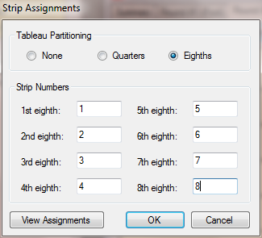
Figure 57: Running a DE in Octants
Running the direct elimination round in this way has a number of advantages:
- You can give the referee for the piste a copy of the tableau and a set of score sheets (use the Print bouts where only one competitor has been determined and Print bouts where neither competitor has been determined options when printing score sheets (figure 56). They can run all the bouts in their octant until only a single competitor remains. Once all the octants are completed then the fencers remaining constitute the quarter-finalists. If the tableau was partitioned into quarters rather than octants then one would have reached the semi-final stage.
- The fencers remain on the same pistes throughout their bouts, there is no need for them to move pistes with all the problems of them not knowing where they should be, or not turning up in time. You can use the View Assignments button on the Strip Assignment dialogue (figure 58) to see an alphabetical list of fencers by piste and print the list so that the fencers know which piste to go to.
- It makes optimal use of referees.
To avoid not knowing what stage a particular octant or quadrant is at and to enable you to print the tableau with results you should ensure that your runners collect the score sheets as soon as possible after matches are completed. You should also reissue your referees with the refreshed tableau.
Again, this means that the referees will be constantly active, you should therefore either have multiple referees per octant or make sure that referees are rotated at intervals.

Which Method to Use
There is no hard and fast rule for running the tableau, the method you use will depend on how many pistes you have, how many referees and how confident you are in keeping control of the competition.

Publishing Interim Results
As each phase of the tableau is completed you should consider replacing the tableau that you have displayed with a refreshed one containing the results. At the same time you should publish the running list of results by clicking on the Results So Far button and printing out the results.
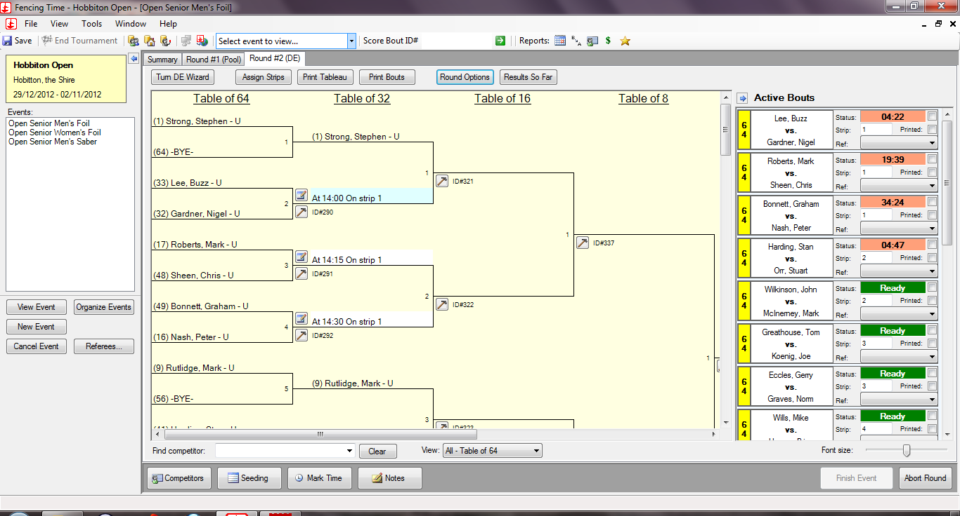
Figure 58: The Top Octant of a DE Tableau

Completion of the Tableau
Once the tableau is complete then you should click on the Finish Event button to complete the competition. This will allow you to print the reports including a set of final rankings.
A window giving classifications will be shown when you click the Finish Event button. This is purely for American tournaments, you can safely click on the OK button at which point a table containing the final rankings will be displayed, as shown in figure 60.
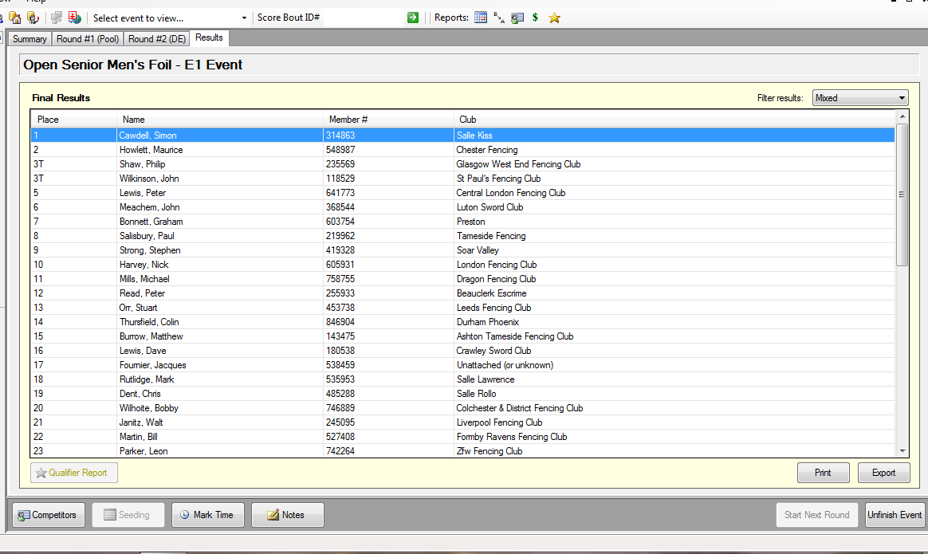
Figure 59: The Final Results

After the Competition

Publishing Final Results

At the Venue
The Print button on the final results (figure 60) can be used to print the final results for display in the appropriate areas.

On the Internet
Fencing Time can export files in a variety of formats, if you want HTML for display on a web site then click on the Export button and select HTML as the format. This will produce a file that contains the final rankings, the results of the poules and the DE tableau.
The HTML file is styled within the file itself, so if you are simply uploading this as a static page then there is no more to be done.
If the results are to be loaded into a database then it is also possible to export the data as a CSV file.

Creating Result Packs
If you need to create a more comprehensive results pack, for example for FIE or EFC sites or for foreign teams then you may need to provide additional information.
- Fencers – a list of fencers who were present can be exported by either using the Competitors button on the Summary tab for the tournament or by selecting the Competitor List report from the View Reports menu.
- Results of Poules – these are included in the export of the final results
- Ranking after the Poules – if you need this then you should ensure that you export it at the time it is generated
- Tableau – this is included in the export of the final results
- Final Results – This is included in the export of the final results
- Activity of Referees – this is available from the Summary tab for the competition.
If you need results in an FIE format then instead of exporting as HTML you should choose either Engarde FFF or FIE XML format, dependent on what is required.

Who Needs the Results?
This depends on the type of competition you are running.
For a regional level event then all you may require is a set of results for your regional committee and web master.
For UK open competitions you will need to provide results for:
- British Fencing – for publication on the web site
- The Sword – for inclusion in the results pages
- Weapon Ranking Coordinators – for calculation of the monthly rankings
For international tournaments you may need to provide results packs for each competing nation, for the FIE or EFC and for the media.

What to Do When it All Goes Wrong

Correcting an Earlier Mistake

In the Poules
You can correct a mistake in the poules up to the time you start a new round. Click on the poule in question on the main poule screen (figure 49) and enter the new results.
If you have followed the procedure for publishing results outlined earlier then you should refuse to correct any errors reported after the DE has started. It is the fencer who is responsible for checking that correct results were entered on the poule sheet and that the printed results are also correct.

In the DE
You can correct a mistake in the DE up to the time that you click on the Finish button to finish the tournament. Select the match that you wish to correct from the tableau display (figure 53) and enter the correct result.
If the tournament has been finished then you need to click on the Unfinish Event button, you can then correct a result in the same way as above.

Restoring a Back Up
At various times during the competition Fencing Time will prompt you to take a back up of the tournament. You should always do so when prompted. The tournament data will normally be stored in a file in the My Tournaments directory. However it may be a good idea to store the data either on a network or USB drive so that if your computer fails during the tournament the information is still available.
In general you will not need to restore from a backup unless you are moving to the tournament to another computer. If, for example, there has been a major mistake in the poule round and you have started the DE round then simply click on the Abort Round button to abort the current round and revert to the previous one.

Copying Data to Another Computer
There are two processes for copying the data between computers:
- Transferring the database
- Copying the tournament files.

Transferring the Database
Transferring a database is a two-step process. The first step is to export the database from the “source” computer’s copy of Fencing Time so that it can be taken to the “destination” computer. To do this, choose the first option presented by the Transfer Database Wizard (running on the source computer’s copy of Fencing Time.) You will be asked to specify a folder where you want the transfer file placed.
After completing this step, Fencing Time will generate a file called “FencingTimeTransferData.ft3”. This file contains all of the information needed to bring the database to a new computer.
The next step is to copy the FencingTimeTransferData.ft3 to the destination computer. You can do this by whatever method is most convenient, e.g. copy it to a USB drive or over the network. Be sure you note where you place the file on the new computer. The desktop is usually a good choice.
The next step requires that Fencing Time is already installed on the destination computer. If you have not already done so, install Fencing Time and then launch it. If you are asked whether you want to create or convert a database file, tell Fencing Time to create a new database. Next, go to the Tools menu and select the Move Master Database to/from Another Computer option to launch the wizard again. This time, you will select the second option presented – the option to import the database.
When prompted, select the folder that contains the FencingTimeTransferData.ft3 that you brought tothe destination computer from the source computer.
Once you have done this, Fencing Time will display a confirmation step before beginning the import process. It is important to understand that the imported database will completely replace all of the data on the destination computer. You will still be able to open tournament files, but any other fencer, club and referee data will be lost.
Once you confirm the import, Fencing Time will replace your database with the one from the source computer. Once complete, you will have access to all of the data that was available on the source computer.
It is recommended that you install Fencing Time on your second computer and do the transfer of the database before the tournament rather than during it. While the transfer is quick it is something that you should avoid doing during the fraught time of running a tournament.

Copying the Tournament Files
All that is necessary is to copy the tournament directory from one computer to the other, either using a USB drive or over the network.

Other Reports
Fencing Time offers some other useful reports:
- On the main competition screen you will see a button Mark Time. Each significant event will have a timestamp attached to it. These include the start of a round, when scoresheets went out, when scoresheets came back and when the tournament finished. You can also add your own events. This is useful if you have disputes since it enables you to provide an audit of what happened during the tournament. It also serves as a planning tool for future years.
- The schedule for the day is available from the View Reports menu, this gives the list of events and the times that they are due to run.
- The final result summary gives a list of the competitors in all the events. Each competitor is listed with the event name, their final place, their club, division, and country affiliations, and their classifications. The major use for this report, which is available as a CSV file, is as a source for a database upload for cumulative results over the years the tournament runs.
- The financial summary report simply tabulates the registration and entry fees.

Produced by the DT Register application which runs in the Joomla! content management system
If you are running multiple rounds of poules then you will be prompted as to how you want to rank from these, however this will not be discussed in this manual.

